2.1

Login

Login

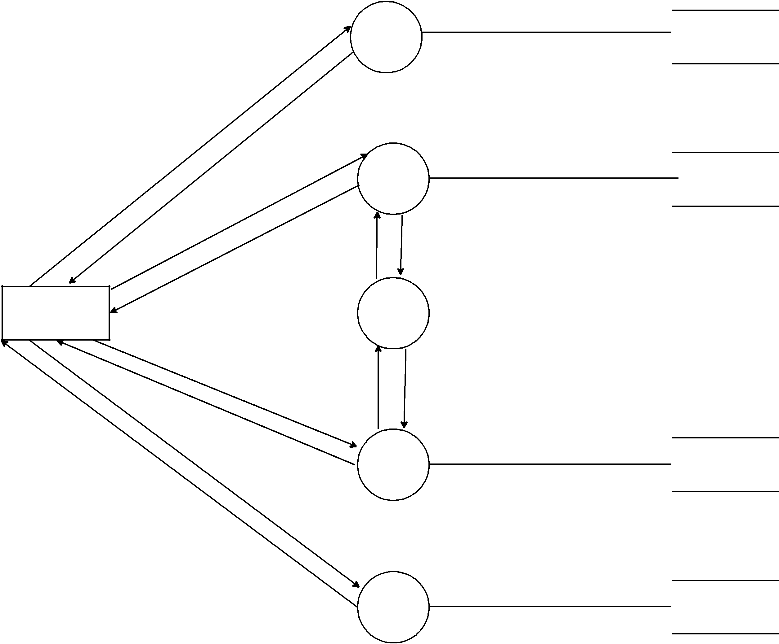

Request

Confirmation

Create
Account

Confirmation

2.2

Create

Account

Information
Request
Received

Create Account

2.2.1

Customer
Customer

Information

Update

Account

Confirmation

Request

Confirmation

Information
Request
Received

2.2.2

Update

Account

Update Account

2.3
Customer

Transaction

Emp_Create_Tran

